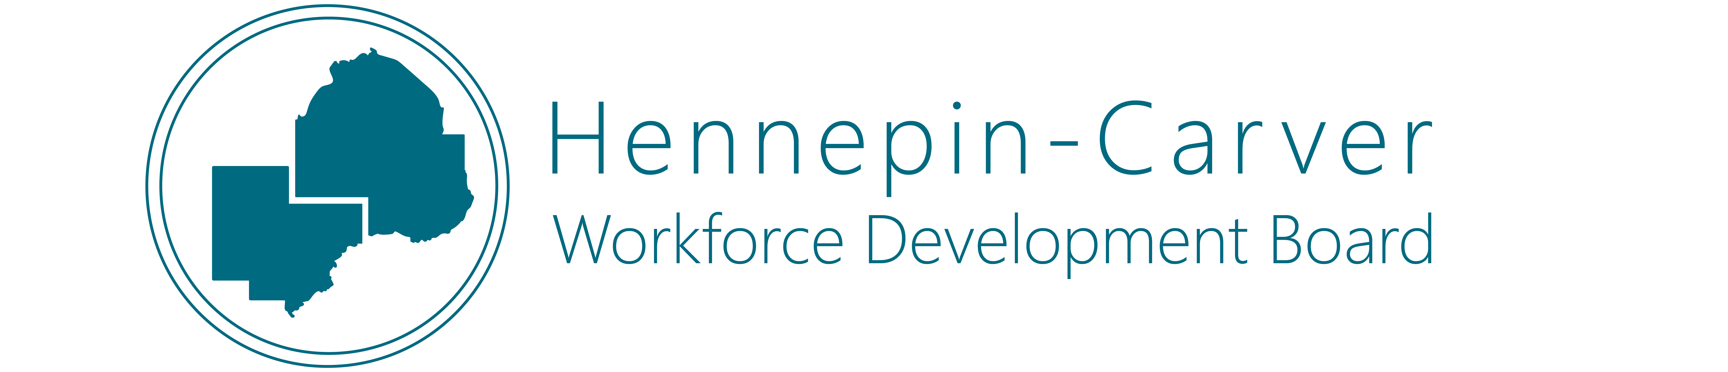

**AGENDA**

**November 14, 2023**

**CareerForce - Bloomington**

**4220 Old Shakopee Road W #200**

**Bloomington, MN 55437**

*_______________________________________________________________________________________*

**Call to Order- Chair Garfield Clark** *Items in red require a vote to move forward*

1. **Approval of Agenda**
2. **Approval of Meeting Minutes (September 2023)**
3. Presentation on Obstacles to Employment for Job Seekers by Erick Garcia Luna, Federal Reserve Bank of Minneapolis.
4. **Board Business**

a. HCWDB Designation of a Comprehensive CareerForce Location for Workforce Development Area 09

b. Approve the purpose, scope and timeline of the Adult, Dislocated Worker, and Youth Request for Proposals.

**Board Work Group Report Outs**

1. **Updates**

Board Updates

Program Updates

* + 1. Wagner-Peyser
    2. Adult/Dislocated Worker
    3. Youth

Carver County

Hennepin County

Other?

1. **Adjourn**

**Mission Statement**

The Hennepin-Carver Workforce Development Board fosters individual and family economic well-being through the development of meaningful career pathways and employment opportunities, provides a skilled talent pipeline to our employer partners through the strategic investment of workforce development resources and the building of collaborative partnerships, and works alongside community organizations to identify and recruit community members to participate in workforce development services based on the workplace requirements expressed by our employer partners as well as the needs and interests of the community.

**Vision Statement**

The board works in partnership with all community members and employers to support and enhance an effective, efficient, and inclusive workforce development system which assures alignment between available talent and employer needs resulting in economic prosperity for all.

*The Hennepin-Carver Workforce Development Board is a Proud Partner of the American Job Center Network and Minnesota CareerForce.*

  